Table of Contents

Goal 2

Solution 2

Exploratory Data Analysis 2

Decompose the series 3

Forecast Using Moving Average & Sesonal Index 4

Forecast Using HoltWinters 6

Conclusion 7

# Goal

The goal of this assignment is to predict the sales for the period June 2017 to December 2018.

# Solution

## Exploratory Data Analysis

Important Observations:

* Definite upward trend
* Definite seasonality
* Does not seem to have outliers
* Does not seem to have long run cycles
* The series is definitely not stationary

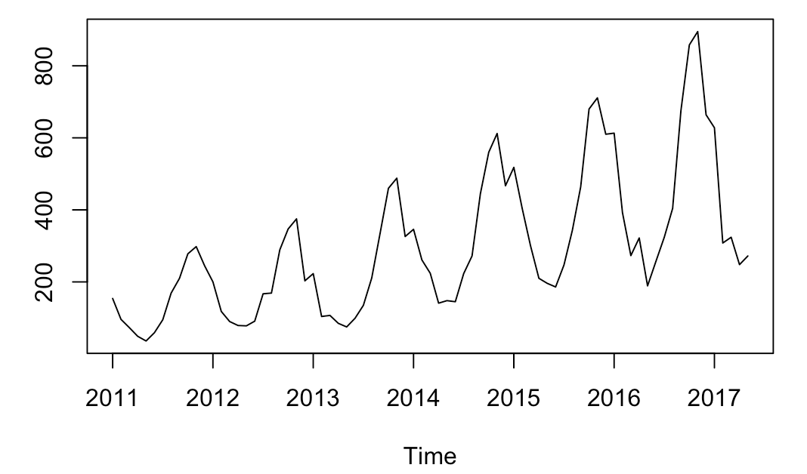

## Decompose the series

Decomposing the series into trend, seasonal and the random part. The Dickey-Fuller Test reveals that the random part is stationary.

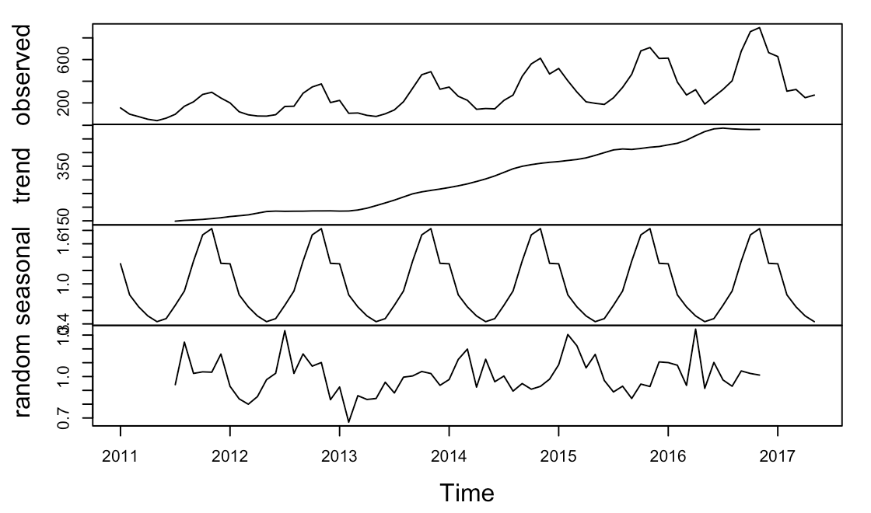

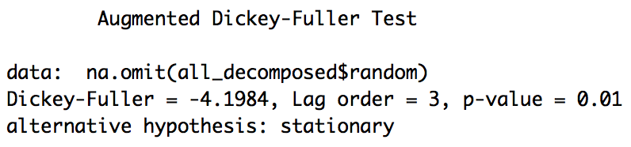

## Forecast Using Moving Average & Sesonal Index

We can de-trend the series using a moving average of 12.

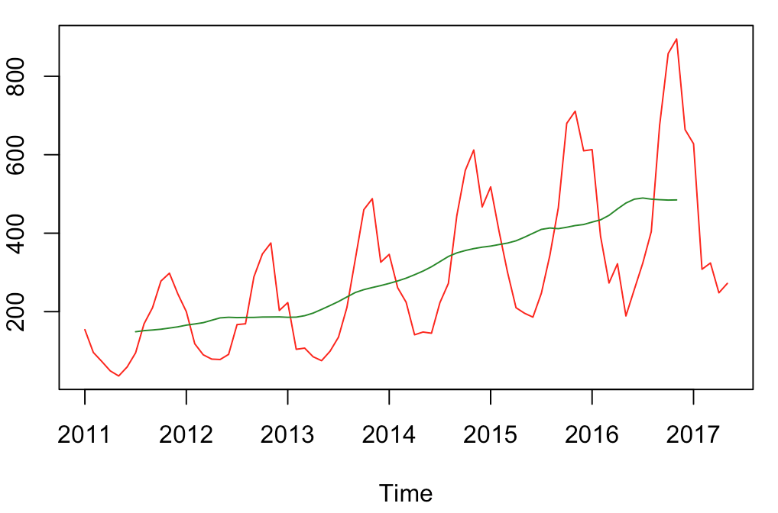

Let us first split the data into train and test. When we forecast we multiply the forecast of the moving average with the seasonality index and calculate the MAPE for the test sample.

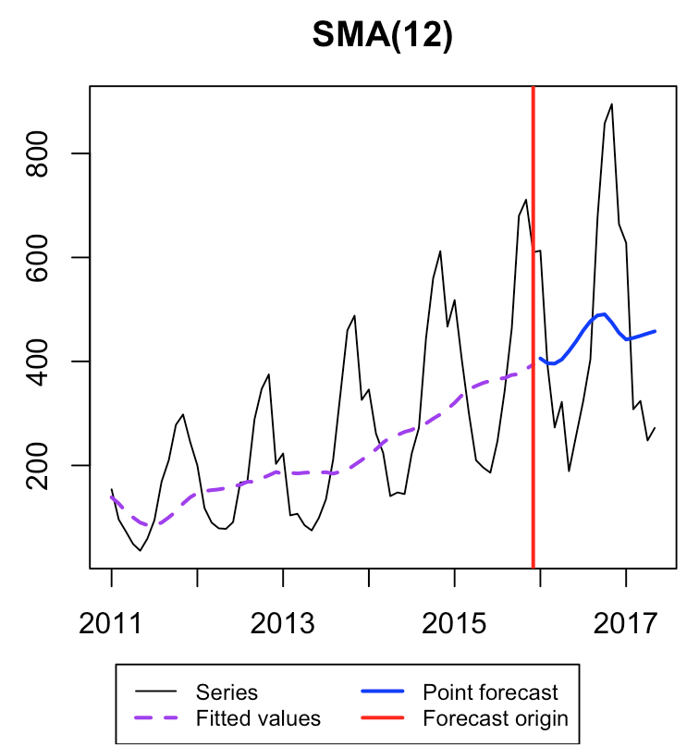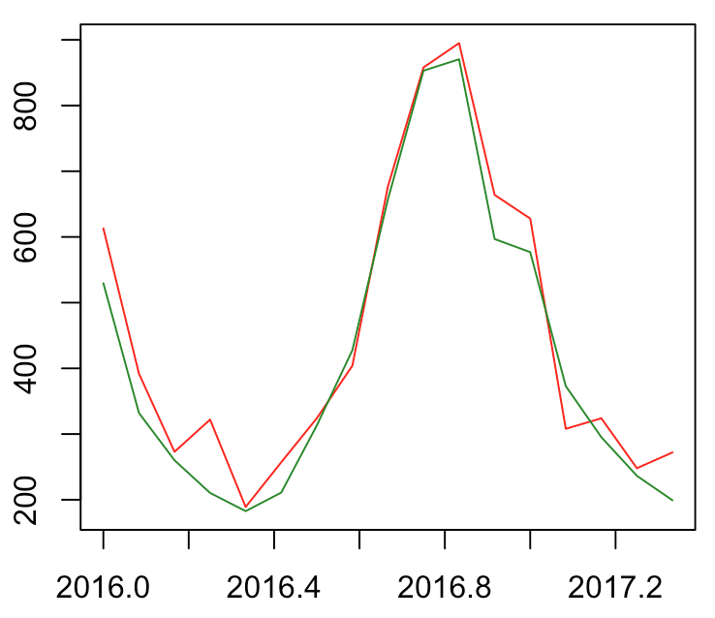

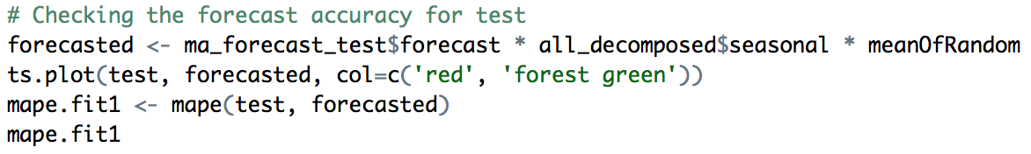

**MAPE:** 10.86%

We then apply the same concept to forecast for the period June 2017 to December 2018.

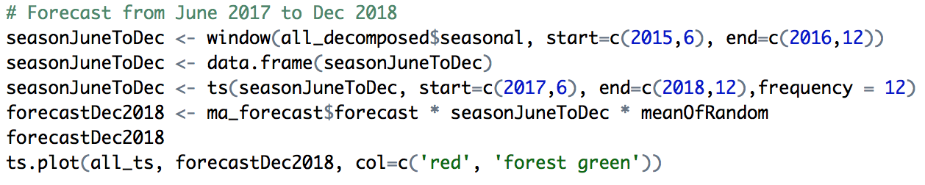

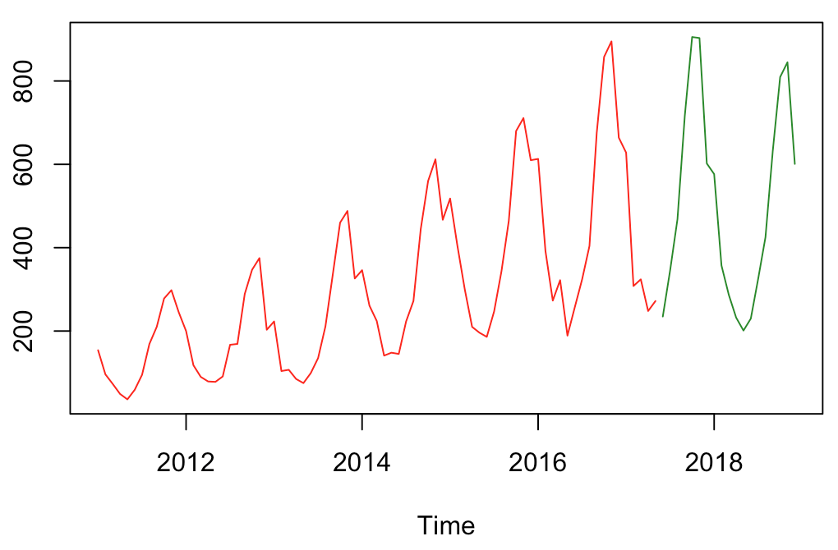

## Forecast Using HoltWinters

We use the HoltWinters approach to forecast sales. In this case we first evaluate the forecast performance on the test data and then forecast the sales for the future period. The following combination gives a MAPE of 12.15%

* alpha: 0.6315059
* beta: 0.01621163
* gamma: 0.4

Forecast of the test data overlapped with the actuals

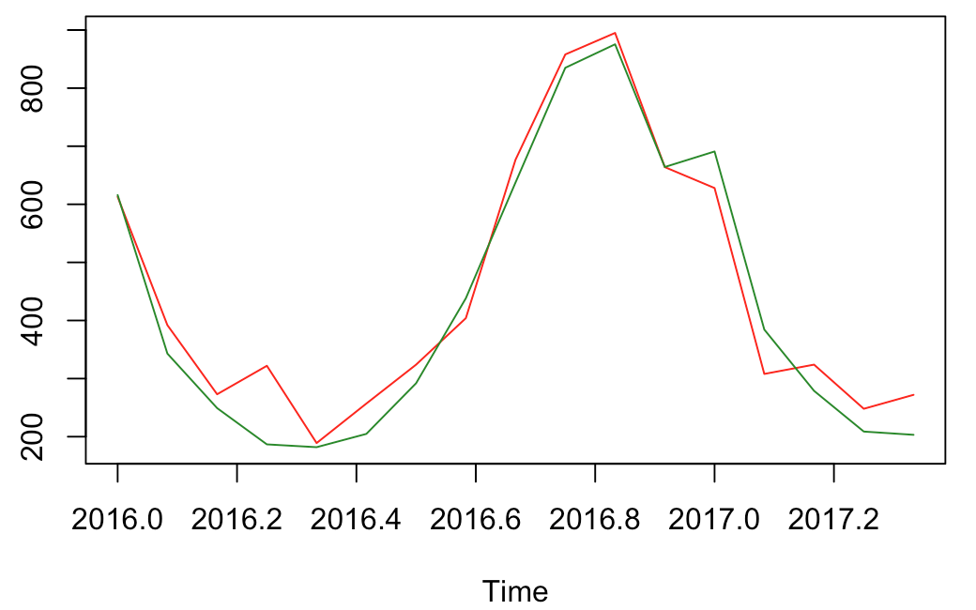

Seems like the model fits well to the past data

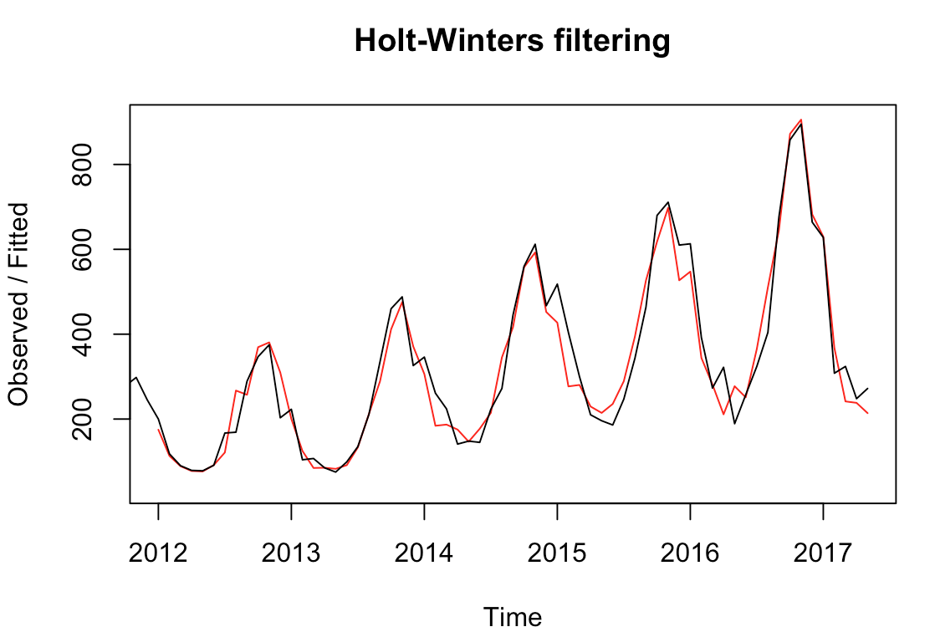

We use the same model to forecast sales for the future period & test for stationarity of the residuals (p-value = 0.03891 < 0.05 hence reject the null hypothesis of a non-stationarity)

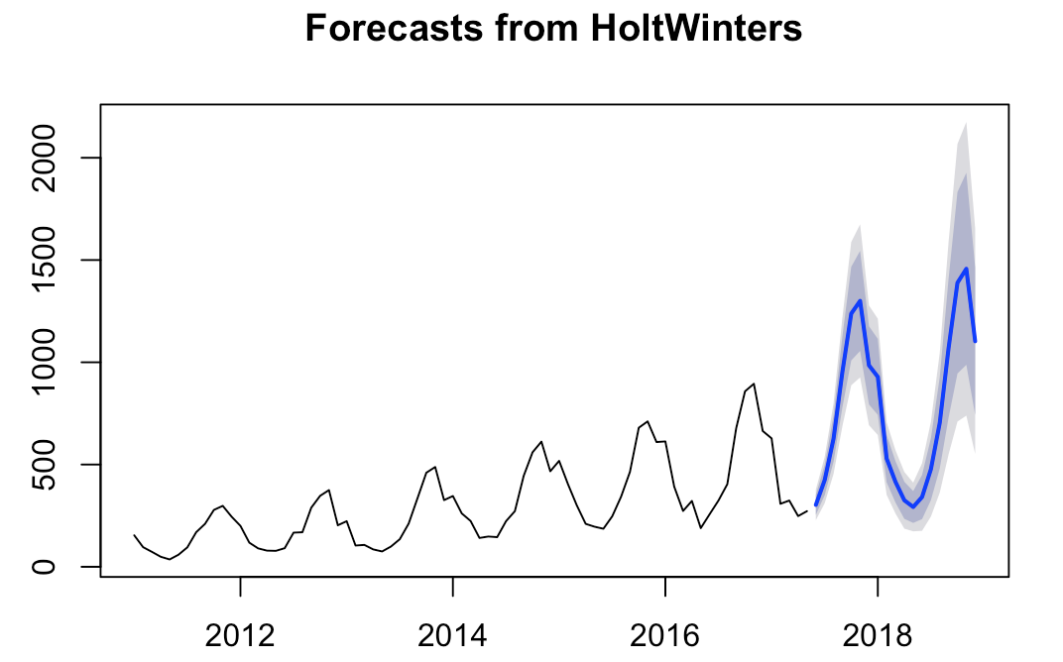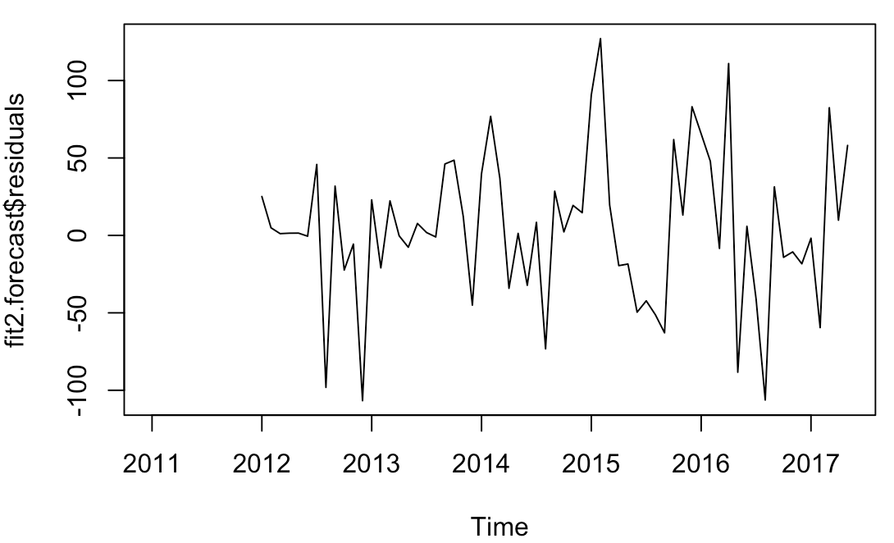

# Conclusion

Although the MAPE is lower for test using the MA * Seasonality Index * Random **I would suggest going with the HoltWinters as it is more accurate when we have seasonality & trend.**

|  |  |  |  |  |  |  |  |
| --- | --- | --- | --- | --- | --- | --- | --- |
| **Year** | **Month** | **MA * Seasonality Index * Random** | **HoltWinters** | | | | |
| **Point Estimate** | **Lo - 80%** | **Hi - 80%** | **Lo - 95%** | **Hi - 95%** |
| 2017 | Jun | 234.75 | 302.61 | 253.83 | 351.40 | 228.01 | 377.22 |
| Jul | 345.60 | 424.00 | 349.94 | 498.06 | 310.74 | 537.26 |
| Aug | 468.34 | 626.41 | 513.79 | 739.03 | 454.17 | 798.65 |
| Sep | 716.60 | 953.14 | 779.49 | 1126.80 | 687.56 | 1218.73 |
| Oct | 905.52 | 1237.98 | 1009.06 | 1466.90 | 887.88 | 1588.09 |
| Nov | 903.12 | 1300.18 | 1055.48 | 1544.88 | 925.94 | 1674.41 |
| Dec | 602.06 | 985.07 | 793.68 | 1176.45 | 692.37 | 1277.77 |
| 2018 | Jan | 576.67 | 928.74 | 742.90 | 1114.58 | 644.53 | 1212.96 |
| Feb | 357.31 | 529.02 | 413.13 | 644.90 | 351.79 | 706.25 |
| Mar | 286.77 | 414.91 | 313.83 | 516.00 | 260.32 | 569.50 |
| Apr | 232.24 | 325.07 | 234.46 | 415.68 | 186.49 | 463.65 |
| May | 201.07 | 292.43 | 214.60 | 370.25 | 173.40 | 411.45 |
| Jun | 229.83 | 341.06 | 233.08 | 449.03 | 175.92 | 506.19 |
| Jul | 324.94 | 477.30 | 325.94 | 628.65 | 245.82 | 708.78 |
| Aug | 425.19 | 704.33 | 481.04 | 927.63 | 362.84 | 1045.83 |
| Sep | 633.07 | 1070.50 | 730.50 | 1410.50 | 550.52 | 1590.48 |
| Oct | 809.45 | 1388.86 | 945.09 | 1832.63 | 710.17 | 2067.55 |
| Nov | 844.94 | 1457.04 | 987.65 | 1926.43 | 739.17 | 2174.91 |
| Dec | 600.96 | 1102.73 | 742.48 | 1462.98 | 551.78 | 1653.68 |